**In This Issue** Monthly meetings Letter from the Chairman AGM 2018 Bridge visit

Did you know?

Living Europe Exhibition

**Monthly meetings**

Monthly meetings are held in the Mayor's Parlour in the Guildhall in Bath Next meetings: all 2 pm on Fridays:

7 September

5 October

30 November

To join, contact Hilary ELMS, Secretary BBTA

208, Old Frome Rd

BATH BA2 5RH

01225 837790

h.elms412@btinternet.com

**The BBTA AGM 2018** was held on Friday 8 June 2018

The following officers were all reelected:

Chairman Bryan Chalker

Vice Chairman Jeremy Key-Pugh

Secretary Hilary Elms

Treasurer/Minutes Sec. Tony Horstmann

There are in addition 6 committee members.

**Letter from the Chairman**



It has been a fairly quiet year so far but, following on from our 17th AGM in June, when Teresa Pokorna from Bath College attended as a guest, we are hoping to raise interest in our Association with students.   
   
Our new Mayor, Cllr. Patrick Anketell-Jones is the 791st to hold this position and his theme for the year is 'The Environment', which falls into line with our recent suggestion of supporting the global ban on plastic pollution - and planting more trees in this World Heritage City. To this end, the Mayor attended our meeting on 3rd August to take matters forward**.**

**Did you know?**

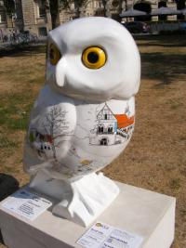

**The Bath Owls**

The Roman Baths Temple, built in the 1st century AD, was dedicated to the Roman goddess Minerva.

Minerva was the Roman goddess of wisdom, healing and the arts whose sacred animal was an owl.

The large owls, which are 1.1m tall will perch on 40cm high plinths, and will be sponsored by a wide range of businesses and organisations. Each owl has been decorated by artists from the West Country and beyond. Smaller 75cm 'Owlets' will also be available  for schools, community groups and charities to sponsor and decorate and will belong to them after the event.

The owls  will take up their perches across Bath and the surrounding region from the end of June 2018.

The picture shows the 'Twinning Owl' with pictures of our 4 Twin Towns: Aix en Provence, Alkmaar, Braunschweig and Kaposvar. Our link with Beppu in Japan is also represented.

Bridge visit

"I have to report a very successful visit to Bath by Ulrike and Markus Görnemann from 17th - 21st May.  They enjoyed the hospitality of the city in the form of entrance to the Baths, Victoria Art Gallery and the Fashion Museum, not to mention the party in the city in the evening.  They played bridge at Bath Bridge Club, and also at a bridge and barbecue on May 19th, hosted by Christine and Stewart MacFarlane (of Bridge and Games, Bath) who also spent a day showing our guests more local sights.

# Very sadly, I also have to report that our bridge contact in Braunschweig, Michael Seiffert (photo below), collapsed and died on the morning of 3rd June.  His family, friends and colleagues there are understandably in total shock and his friends in Bath have sent many messages of deepest sympathy:  Michael was a charming, witty and admirable man.  Bridge and Games, Bath, are planning to inaugurate an annual competition this autumn in his memory, to be known as "The Brunswick Trophy" and which will take the shape of a painting recently gifted to us by Ulrike and Markus Görnemann."

Judy Spencer

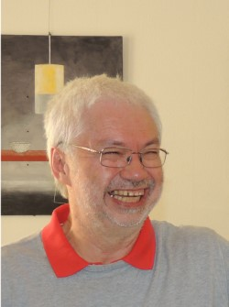

**European Year of Cultural Heritage 2018**

As part of the EYCH 2018 I participated in an Arts and Craft Fair in Braunschweig from 21 to 31 July. The city had invited representatives from 3 of its twin towns - Bath, Nîmes and Sousse. I took and displayed about 50 small items from the Aqua Glass Studio. The representative from Nîmes displayed his own copper engravings and the Tunisians from Sousse offered traditional clothing and sandals. Although the event was not particularly well attended, probably on account of the fact that it was the holiday period and also very hot, those who came showed interest and many were happy to chat about their various visits to England.

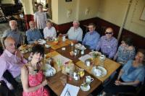

If you would like to practise your German in a friendly informal atmosphere over ‘Kaffe und Kuchen’ come to the Stammtisch - every Wednesday throughout the year about midday at the Café Retro, York St, Bath (near Bog Island)

Further Stammtische may take place some evenings at *The Thief*  pub in Monmouth St

(further details from *philippa@harringtonglass.co.uk*)